AWS Task 3
Launch an EC2 instance (Linux and Windows) along with a web server. Then, create an EBS volume of 5 GB, attach it to an EC2 machine (Linux and Windows), and take a snapshot. Finally, create an EBS volume using the taken snapshot.

EC2 Instance:
Linux & Windows:
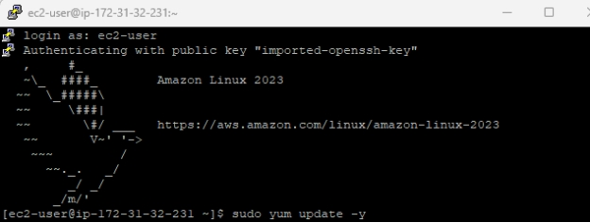
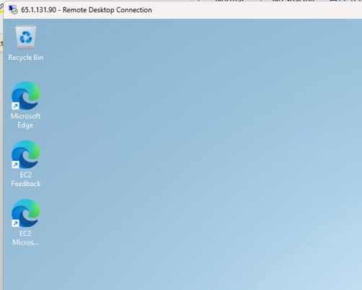
Volume Mounted Linux and Windows:

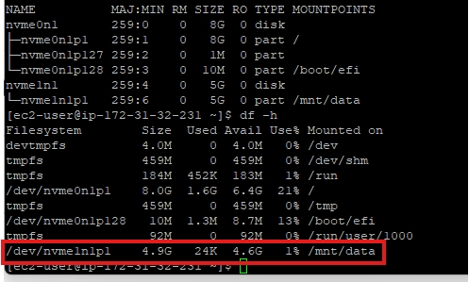
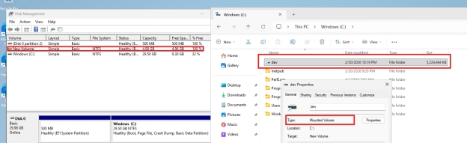

Snapshot:
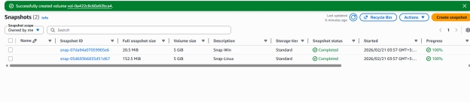

EBS volume using the taken snapshot.

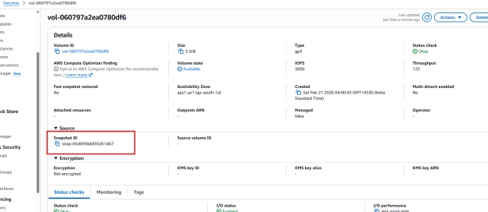
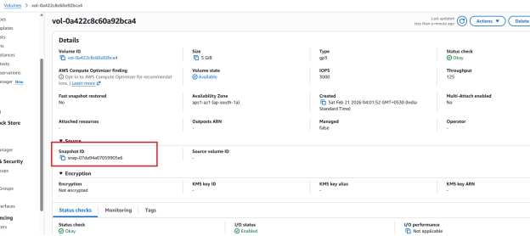

2. Launch two ec2-instances and connect it to a application load balancer, where the output traffic from the server must be an load balancer IP address.

EC2 Created:
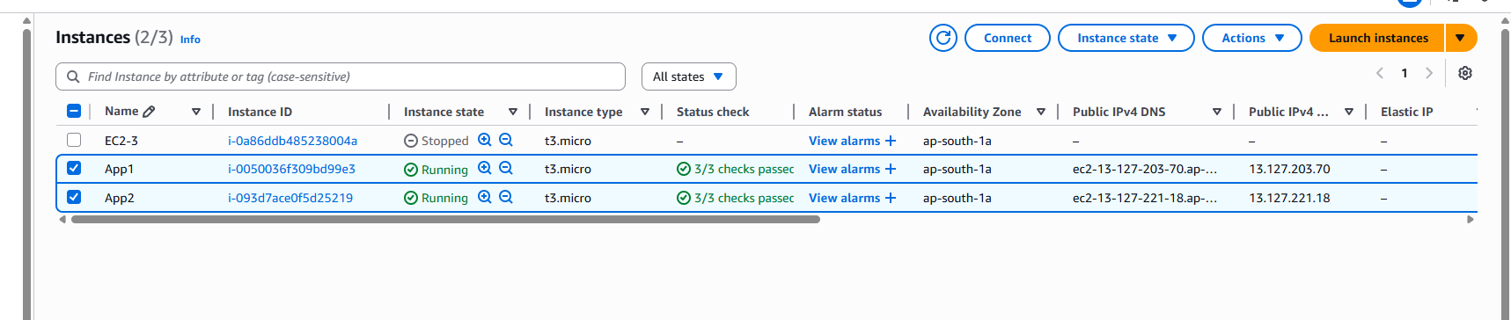
application load balancer:
Load balancer created and 2 target groups attached.
